WEBER AUCTIONS
(Term Project of Component Based Software Engineering)



M.Sc. Fall 2003

Resource Person
Mr. Rizwan Muhammad Yousaf

Submitted By
Mr. Ahsan Mahboob (MCSF03M012)
Mr. Muhammad Ali (MCSF03M001)

Date: Wednesday, July 20, 2005

University College of Information Technology
University of the Punjab Lahore
Table of Contents

1 Introduction 4
2 Existing System 4
2.1 Problems with the Existing System 4
2.2 Suggested Solution 4
2.3 Business Organization 4
2.4 Business Organization Chart 5
3 Scope of the System 6
4 Summary of Requirements 6
4.1 Auction Management 6
4.2 Carpet Management 6
4.3 Customer Management 6
4.4 User Management 6
4.5 Freight Management 6
4.6 Customer Registration 6
4.7 Enter Bid 7
5 Business Process Modeling 7
5.1 Scenario 7
5.1.1 Use Case: Enter Bid 7
5.1.2 Business Use Case Realization 7
5.1.3 Focusing on Process Automation 9
5.1.4 Focusing on Information Process 12
6 Business Areas of Organization 15
7 Business Use Case Diagram 16
8 Requirement Traceability Matrices and Context Level DFDs 17
8.1 Auction Management System 17
8.2 Carpet Management System 18
8.3 Enter Bid System 19
9 Use Case Description 20
9.1 Use Case Name: Add Auction << UC-01-01 >> 20
9.1.1 Scenario 20
9.1.2 Summary Detail 20
9.1.3 Business Rules/Notes 20
9.1.4 Alternate Course 20
9.1.5 Exceptional Course 21
9.2 Use Case Name: Enter Bid << UC-02-01 >> 22
9.2.1 Scenario 22
9.2.2 Summary Detail 22
9.2.3 Business Rules/Notes 22
9.2.4 Alternate Course 22
9.2.5 Exceptional Course 23
9.3 Use Case Name: Add Carpet << UC-03-01 >> 24
9.3.1 Description 24
9.3.2 Scenario 24
9.3.3 Summary Detail 24
9.3.4 Business Rules/Notes 24
9.3.5 Alternate Course 25
9.3.6 Exceptional Course 25
10 State Chart Diagrams 26
10.1 Auction Management 26
10.2 Carpet Management 27
10.3 Enter Bidding 28
11 Business Sequence Diagrams 29
11.1 BSD of Use Case: Auction Management 29
11.2 BSD of Use Case: Carpet Management 30
11.3 BSD of Use Case: Enter Bidding 31
12 Pseudo Codes 32
12.1 Pseudo Code: Auction Management 32
12.2 Pseudo Code: Carpet Management 32
12.3 Pseudo Code: Enter Bidding 33
13 Analysis Use Case Diagram 34
14 Design Class Diagram 36
15 Component Identification 37
16 Component Analysis Diagram 38
17 Component Class Diagram 39
18 Interface and Functional Specification 40
19 Analysis Sequence Diagram 41
19.1 Use Case: Enter Bidding 41
20 Component Design Diagram with BC Tiers 42
21 Weber Auctions Site Map 43
21.1 Enter Biding Screen 43
22 Component Class Design Diagram 44
23 Design Sequence Diagram UDC & WDC 46
23.1 Pseudo code 47

Introduction
‘Weber’ is well known for its carpet selling business, and has clients throughout the world. At ‘Weber’, High standard printed Catalogue technique is used to distribute latest information, among ‘Weber’ clients, about the carpets available for auction. Website that will develop with the purpose of replacing this printed catalogue system. The visitors of website will facilitated to view available carpets real auction information i.e. which carpet is auctioned, on which price the carpet is being sold etc. The registered users of website can take part in online auction via phone.

Existing System
Currently, the mode of operations at Weber is manual. It is having its offices opened throughout the entire world. It works via high standard printed catalogues that are sent to the clients either upon request or to inform them about the latest information, auctions and bidding etc.

Problems with the Existing System
But this method of working has many short comes, including …
- Delayed response.
- Lacking in up-to-date information.
- Difficulties in informing the clients about the latest information.
- Increases company expenses to much extent.

Suggested Solution
The suggest solution is to make an online highly interactive website that will maintain the latest information about the bidding, auctions and the carpets. These carpets are viewable in the showroom area, but for the registered users. Registered users will be enjoying some more benefits, but visitors will also have a limited (viewable) access to few areas of the system.

- Visitors
  - Facilitated to view available carpets real auction information.
  - Which carpet is auctioned?
  - On which price the carpet is being sold?
  - Etc.

- Registered users
  - All the benefits of visitors including,
  - Taking part in online auction via phone.

Business Organization
Weber deals in the following key business areas …

- Auction Management
- Carpet Management
- Freight Management
- Customer Management
- User Management
- Enter Bid
- Customer Registration

Business Organization Chart

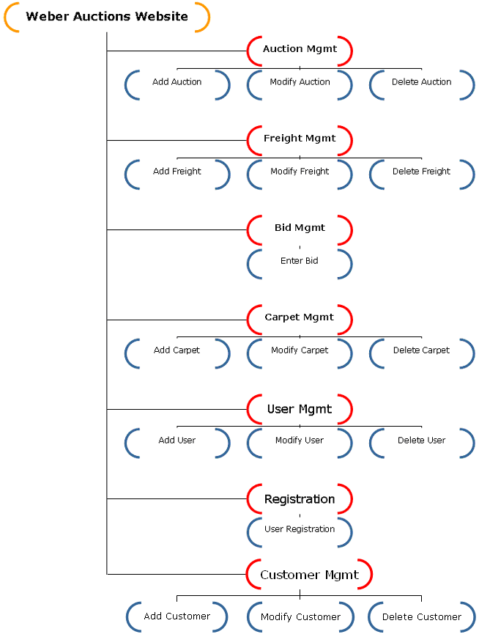

Scope of the System
Data entry operator(s) will enter the data of carpets in the database for a specific auction. These carpets can be viewed in the showroom page. The registered users will browse the showroom and get registered with the site to participate in the auction.

Summary of Requirements

Auction Management
Auction List configuration should be done by the system administrator, who is able to do the ‘Auction Management’. Operations include …
- Add auction.
- Modify auction.
- Delete auction.

Carpet Management
Carpet management is done by authorized users who are able to log into the system with read/write access to it. Operations include …
- Add carpet.
- Modify carpet.
- Delete carpet.

Customer Management
Customer Management is also done by authorized users. Operations include …
- Add Customer
- Modify Customer
- Generate Logins

User Management
User Management is done by System Administrator. Operation Include …
- Add User
- Modify User
- Delete User

Freight Management
This responsibility is solely assigned to the system administrator, who is capable of managing the Freight within the system. Operations include …
- Add freight.
- Modify freight.
- Delete freight.

Customer Registration
Only registered users can participate in the auctions. So a user must be able to register himself to the system by requesting registration.

Customer fills out the form on Weber Auctions web site and requests for registration. After that, Administrator authenticates the registration and generates login information for customer and sends him via email.

Enter Bid
Bidding should also be entered by someone, who is the registered user at Weber Auctions. Customer login to the system and after authentication, he selects carpet for bid and enter bid price for that carpet. And then submit his bid to the system.

Business Process Modeling

Scenario

Use Case: Enter Bid
- Mr. Faisal, who is the auction manager in ‘Weber Auctions’ Lahore branch, announces an auction of carpets.
- He decides about the date of auction, selects carpets for auction and decide initial bid amount of selected carpets.
- He then provides the auction details to Mr. Fida, who is the inventory manager of Lahore branch.
- Mr. Ahmed wants to enter a bid for current auction of carpets.
- He is a new customer to Weber Auctions and not registered yet.
- He arrives at Weber Auction’s Lahore branch office and goes to registration manager and asks for registration.
- Registration manager asks to provide registration details.
- After getting details from Mr. Ahmed, registration manager register him and confirms his registration to him.
- After Registration, Mr. Ahmed approaches to inventory and ask for details of auctioned carpets.
- Inventory manager provides a catalog of carpets.
- Mr. Ahmed selects a carpet and goes to Bid Manager to submit his bid amount for that carpet.
- Bid Manager saves his Bid and confirms him.

Business Use Case Realization
      - Business Actors
- Customer
- Auction Manager
      - Business Workers
- Inventory Manager
- Bid Manager
- Registration Manager

Sequence Diagram for Business Actors and Business Workers

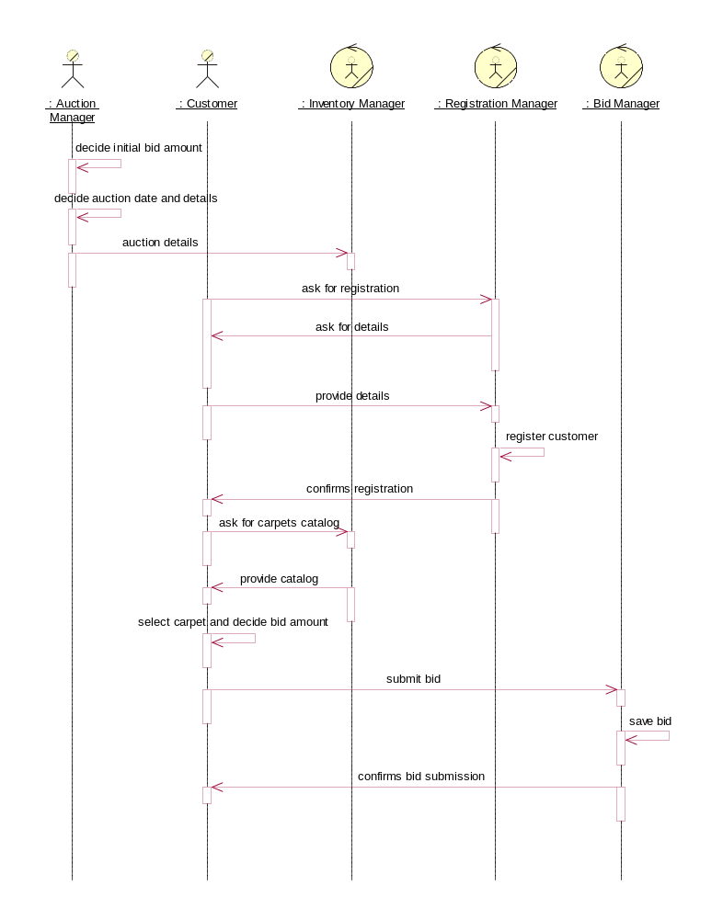

Responsibility Model for Business Actors and Business Workers

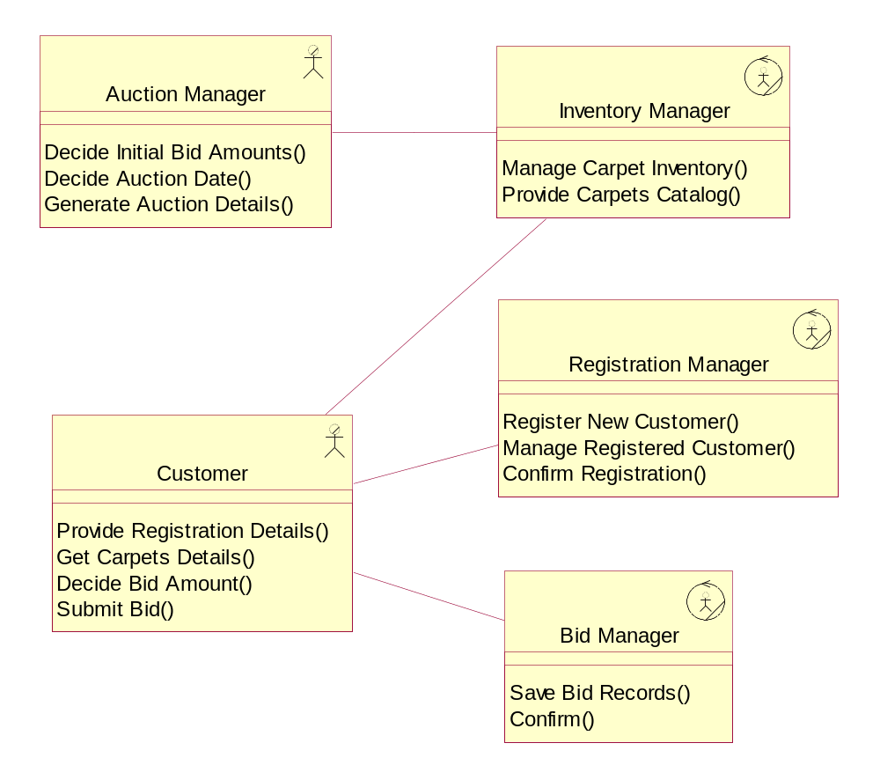

Focusing on Process Automation

Automaton Systems
- Auction Management System
- Customer Registration System
- Enter Bid System
- Carpet Management System

Sequence Diagram for Business Actors, Business Workers and System

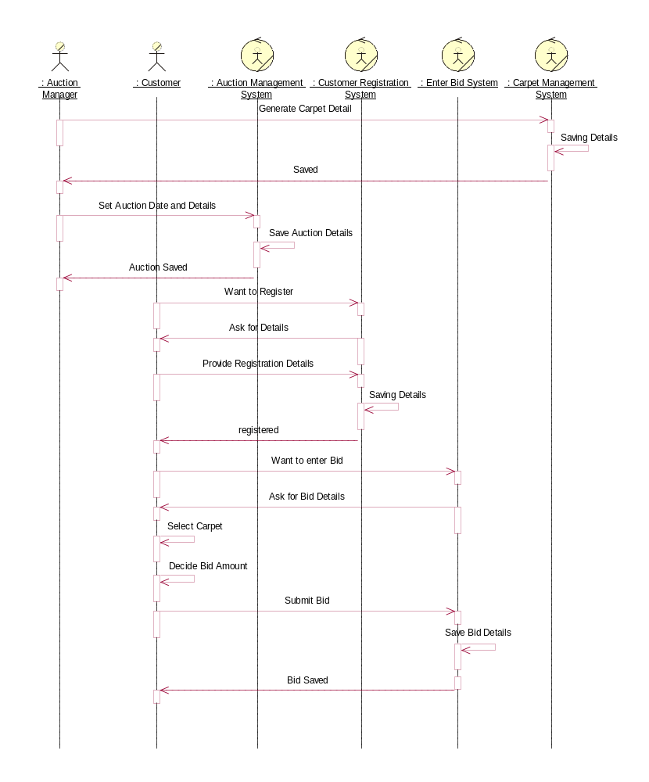

Business Objects Model

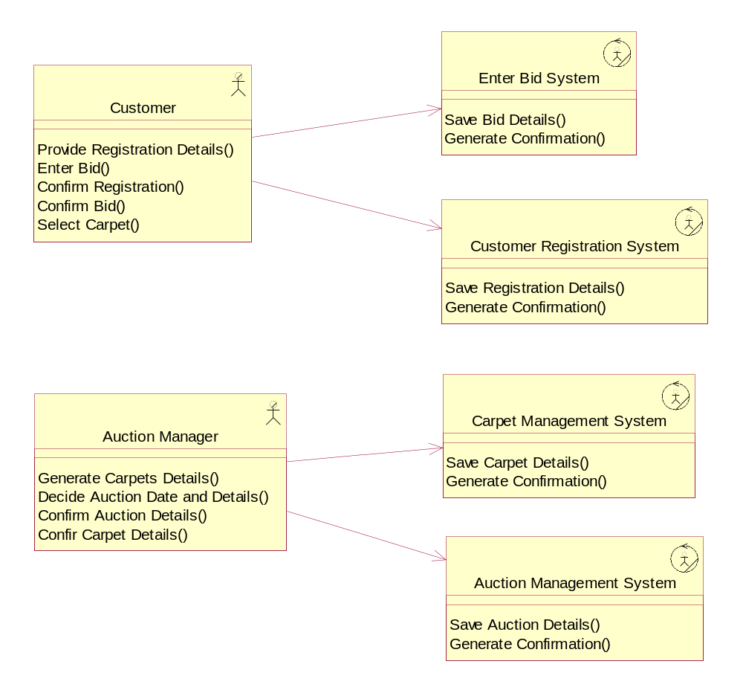

System Use Case Diagram

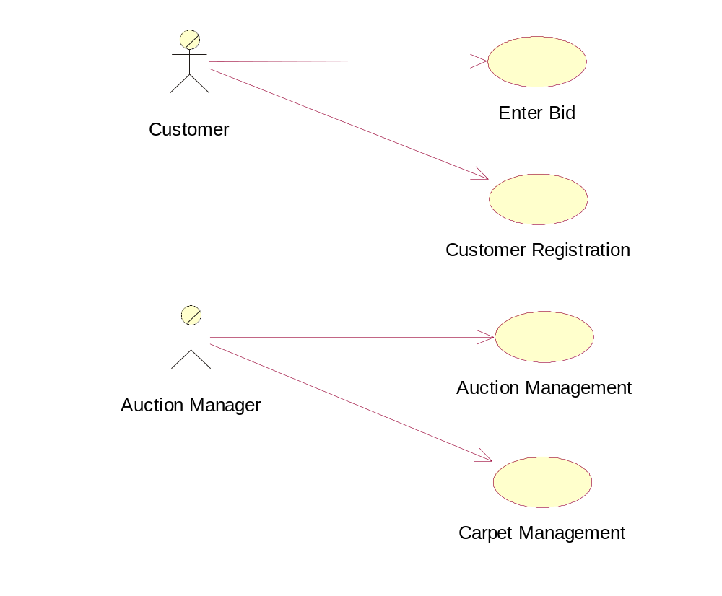

Focusing on Information Process

Business Entities

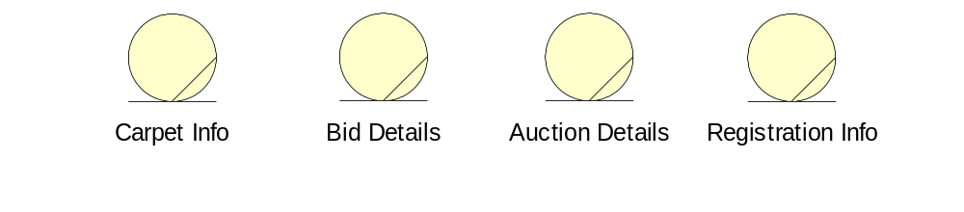

Sequence Diagram for Business Actors, Business Workers and Business Entities

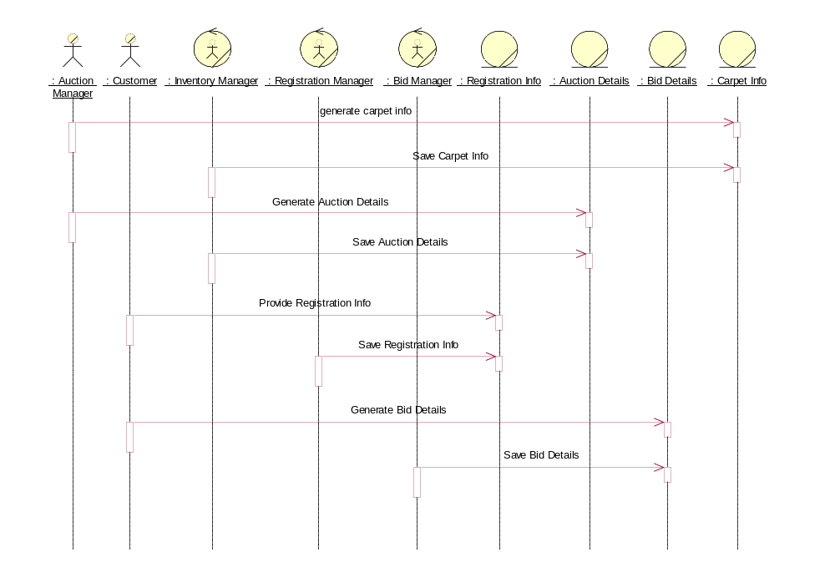

Responsibility Model for Business Actors, Business Workers and Business Entities

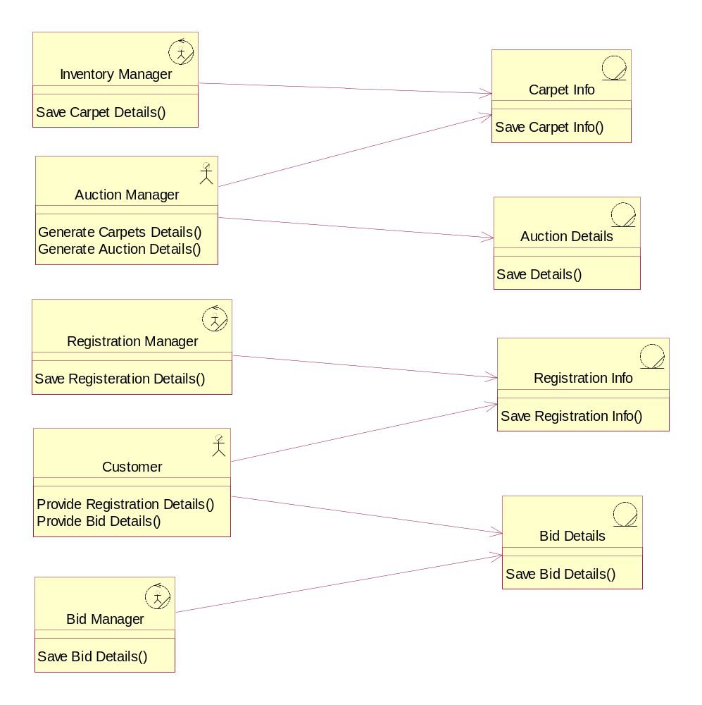

Business Areas of Organization

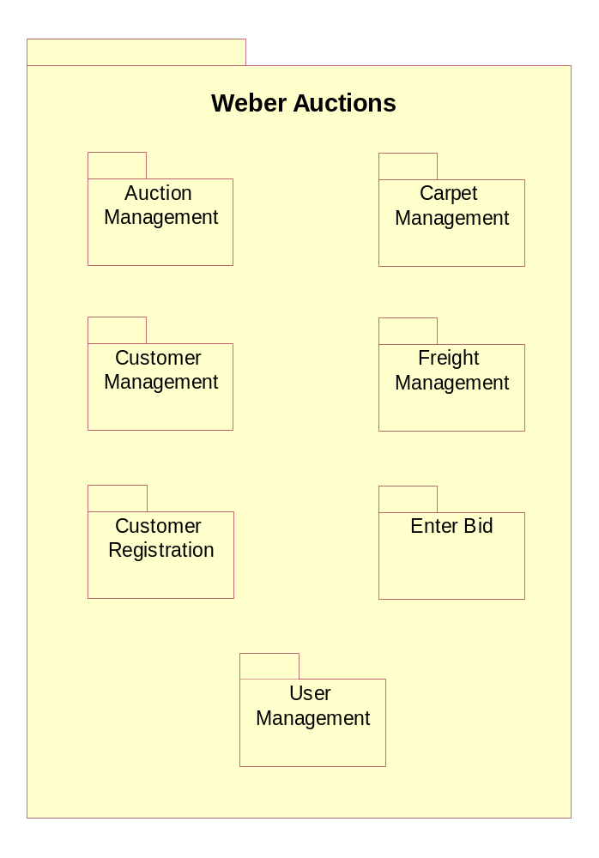

Business Use Case Diagram

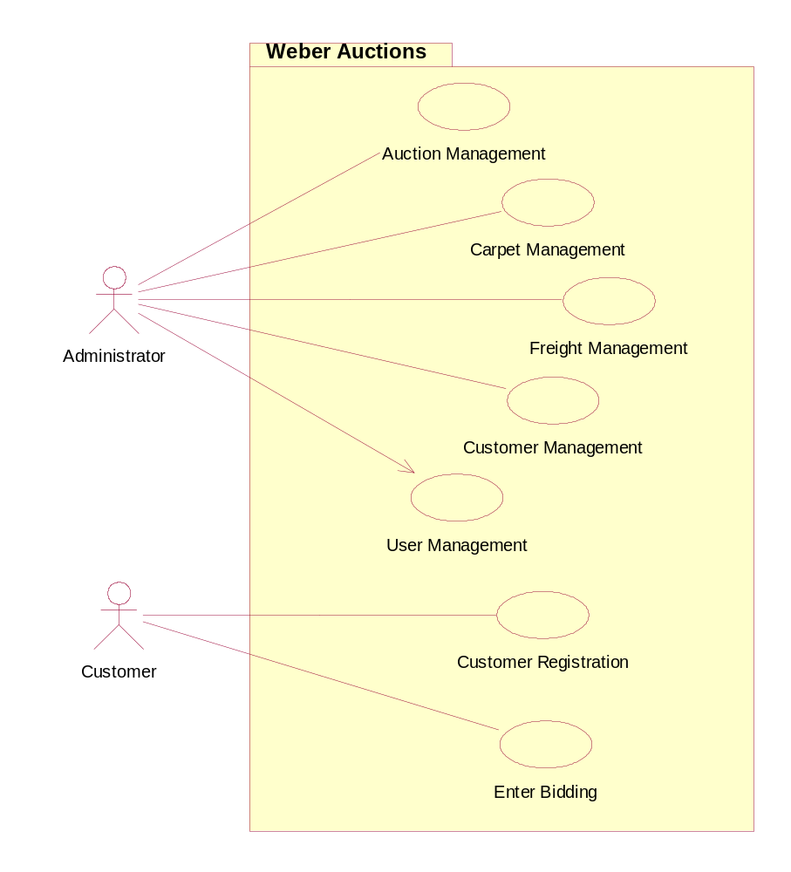

Requirement Traceability Matrices and Context Level DFDs

Auction Management System

Auction Mgmt System

Database
Add New Auction
Modify Auction Details
Delete Auction
Decide Auction Date
Auction Details
Confirmation
Save Auction Details
Update Details
Delete Auction Details
Auction Details
Administrator

Sr. # | Rank | Initial Requirements | Use Case ID | Use Case Name
1 | Highest | Administrator shall add the auction | UC-01-01 | Add Auction
2 | Highest | Administrator shall decide the auction date | UC-01-01 | Add Auction
3 | Medium | Administrator shall modify the details of any of the added auction(s) | UC-01-02 | Modify Auction
4 | Medium | Administrator shall delete an auction | UC-01-03 | Delete Auction
5 | Medium | Auction Mgmt system will confirm the administrator about the successful addition | UC-01-0X | ___

Note
- UC-01-0X indicates that it is applicable to all of the above mentioned use cases
- ___ means that this use case name is among all of the above use cases

Carpet Management System

Carpet Mgmt System

Database
Add Carpet
Modify Carpet Details
Delete Carpet
Decide Initial Bid
Amount
Confirmation
Save Carpet Details
Update Details
Delete Carpet
Carpet Details

Administrator

Sr. # | Rank | Initial Requirements | Use Case ID | Use Case Name
1 | Highest | Administrator shall add the carpet | UC-03-01 | Add Carpet
2 | Medium | Administrator shall modify a carpet | UC-03-02 | Modify Carpet
3 | Medium | Administrator shall delete a carpet | UC-03-03 | Delete Carpet
4 | Highest | Administrator shall decide the initial bid amount | UC-02-01 | Enter Bid
5 | Medium | Auction Mgmt system will confirm the administrator about the successful addition | UC-0X-0X | ___

Note
- UC-0X-0X indicates that it is applicable to all of the above mentioned use cases
- ___ means that this use case name is among all of the above use cases

Enter Bid System

Enter Bid System
Bid Price
Confirmation
Save Bid
Select Carpet
Carpet Management System
Carpets List

Database
Customer

Sr. # | Rank | Initial Requirements | Use Case ID | Use Case Name
1 | Highest | Customer shall select the carpet | UC-02-01 | Enter Bid
2 | Highest | Customer shall enter the bid price | UC-02-01 | Enter Bid
3 | Medium | Bid Mgmt system will confirm the administrator about the successful addition | UC-02-0X | ___

Note
- UC-02-0X indicates that it is applicable to all of the above mentioned use cases
- ___ means that this use case name is among all of the above use cases

Use Case Description

USE CASE NUMBER | USE CASE NAME
UC-01-01 | Add Auction

Description
This document details the Add Auction Use Case, which adds a new auction in the database.

Use Case Name: Add Auction << UC-01-01 >>

Scenario
- The user types the description.
- The user selects the “Auction Date”.
- The user types start time in “Start Time”.
- The user types end time in “End Time”.
- The user clicks the “Add” button.

Summary Detail
Major Function Name | Auction Management.
Description | The ability to do auction management through web.
Function Area | Auction Management.
Business Event Trigger | Administrator adds a new auction.
Actors | Administrator.
Pre-Conditions | - Administrator is identified and authenticated.  - “Auction Management” screen is presented to administrator.
Main Path Outcome | A new auction is added in the database.
Alternative Outcomes | Administrator cancels the auction during the process.
Post-Conditions | - Auction is created and saved in the database.  - Screen is ready for the next entry.

Business Rules/Notes
Rule Number | Rule Name | Rule Details
R1 | Authorization Rule. | Auction can only be added by administrator, who is authorized and authenticated.

Alternate Course
Step | Actor | Action by Actor | System Msg/Notes
A1 | System | User types invalid start time.
A1.1 | System | Error Screen. | Screen with message “Invalid start time”
A2 | System | User types invalid end time.
A2.1 | System | Error Screen. | Screen with message “Invalid end time”
A3 | System | User types start time more than the end time.
A3.1 | System | Error Screen. | Screen with message “Start time should be less than the end time”

Exceptional Course
Step | Actor | Action by Actor | System Msg/Notes
Ex | System | System crashes / Database down.
Ex.1 | System | System generates the error message. | Screen with message “Server is not responding, please try again later”

USE CASE NUMBER | USE CASE NAME
UC-02-01 | Enter Bid

Description
This document details the Enter Bid Use Case, which enters a new bid for the selected carpet from a registered customer in the database.

Use Case Name: Enter Bid << UC-02-01 >>

Scenario
- The user selects “Carpet ID”.
- The user selects “Customer”.
- The user types “Price”.
- The user clicks the “Submit” button.

Summary Detail
Major Function Name | Bid Management.
Description | The ability to perform bid management.
Function Area | Bid Management.
Business Event Trigger | Administrator wants to enter a bid.
Actors | Administrator.
Pre-Conditions | - Administrator is identified and authenticated.  - “Enter Bidding” screen is presented to administrator.
Main Path Outcome | Bidding price is saved in the database.
Alternative Outcomes | Administrator cancels the bid during the process.
Post-Conditions | - Bid is entered and saved in the database.  - Screen is ready for the next entry.

Business Rules/Notes
Rule Number | Rule Name | Rule Details
R1 | Authorization Rule. | Bid can only be entered by user, who is authorized and authenticated.

Alternate Course
Step | Actor | Action by Actor | System Msg/Notes
A1 | System | User did not select “Carpet ID”
A1.1 | System | Error Screen | Screen with message “Select Carpet ID”
A2 | System | User did not select “Customer ID”
A2.1 | System | Error Screen. | Screen with message “Select Customer ID”
A3 | System | User enters invalid price.
A3.1 | System | Error Screen. | Screen with message “Invalid Price”
A4 | System | User enters less or equal bidding price.
A4.1 | System | Error Screen. | Screen with message “Price should be greater than start price”

Exceptional Course
Step | Actor | Action by Actor | System Msg/Notes
Ex | System | System crashes / Database down.
Ex.1 | System | System generates the error message. | Screen with message “Server is not responding, please try again later”

USE CASE NUMBER | USE CASE NAME
UC-03-01 | Add Carpet

Use Case Name: Add Carpet << UC-03-01 >>

Description
This document details the Add Carpet Use Case, which enters a new carpet in the database.

Scenario
- The user selects “Category”.
- The user selects “Auction”.
- The user types carpet ID.
- The user types carpet name.
- The user types description.
- The user types length.
- The user types width.
- The user types weight (kg).
- The user types image file.
- The user types start price.
- The user clicks the “Submit” button.

Summary Detail
Major Function Name | Carpet Management.
Description | Helps in carpet management, that is, addition modification, etc.
Function Area | Carpet Management.
Business Event Trigger | Administrator wants to enter a carpet.
Actors | Administrator.
Pre-Conditions | - Administrator is identified and authenticated.  - “Enter Bidding” screen is presented to administrator.
Main Path Outcome | Carpet is added in the database.
Alternative Outcomes | Administrator cancels the addition during the process.
Post-Conditions | - Carpet is added and saved in the database.  - Screen is ready for the next entry.

Business Rules/Notes
Rule Number | Rule Name | Rule Details
R1 | Authorization Rule. | Carpet can only be entered by administrator, who is authorized and authenticated.

Alternate Course
Step | Actor | Action by Actor | System Msg/Notes
A1 | System | Carpet ID is invalid
A1.1 | System | Error Screen | Screen with message “Invalid Carpet ID”
A2 | System | Carpet ID already exists.
A2.1 | System | Error Screen. | Screen with message “Carpet ID already exists”
A3 | System | User enters invalid length.
A3.1 | System | Error Screen. | Screen with message “Invalid Length”
A4 | System | User enters invalid width.
A4.1 | System | Error Screen. | Screen with message “Invalid Width”
A5 | System | User enters invalid weight.
A5.1 | System | Error Screen. | Screen with message “Invalid Weight”
A6 | System | User enters invalid start price.
A6.1 | System | Error Screen. | Screen with message “Invalid Start Price”

Exceptional Course
Step | Actor | Action by Actor | System Msg/Notes
Ex | System | System crashes / Database down.
Ex.1 | System | System generates the error message. | Screen with message “Server is not responding, please try again later”

State Chart Diagrams

Auction Management

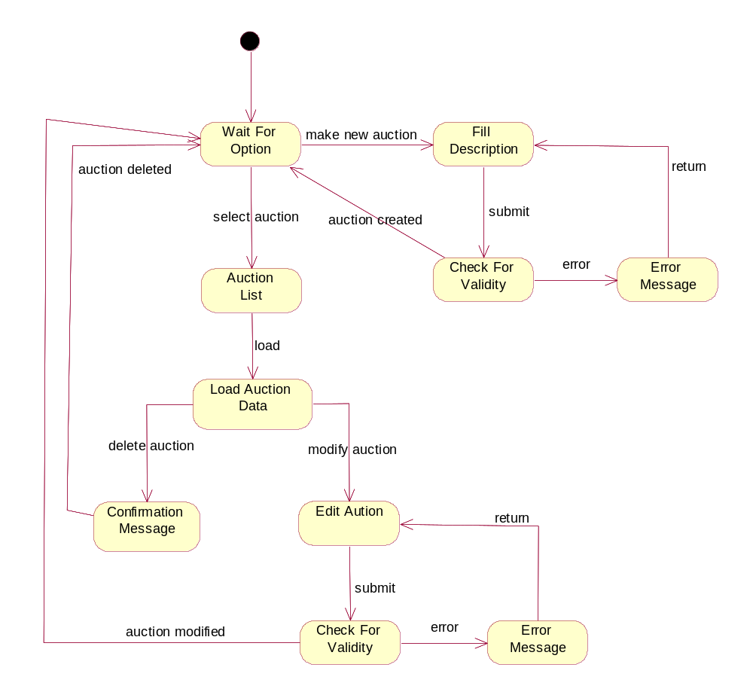

Carpet Management

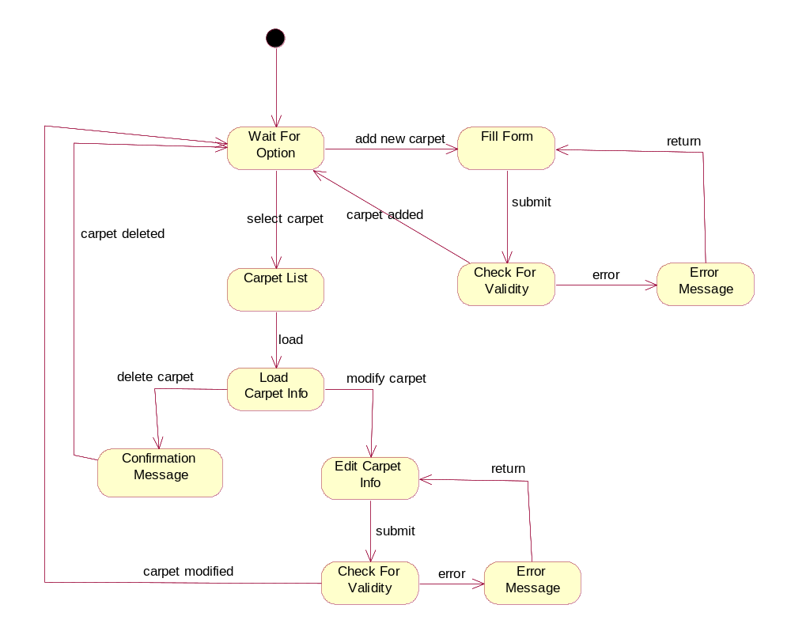

Enter Bidding

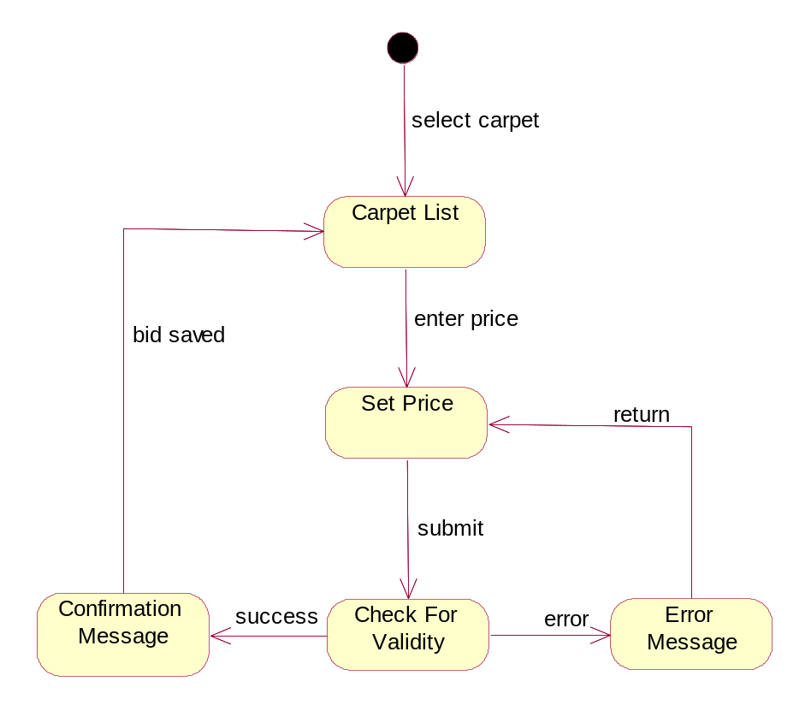

Business Sequence Diagrams

BSD of Use Case: Auction Management

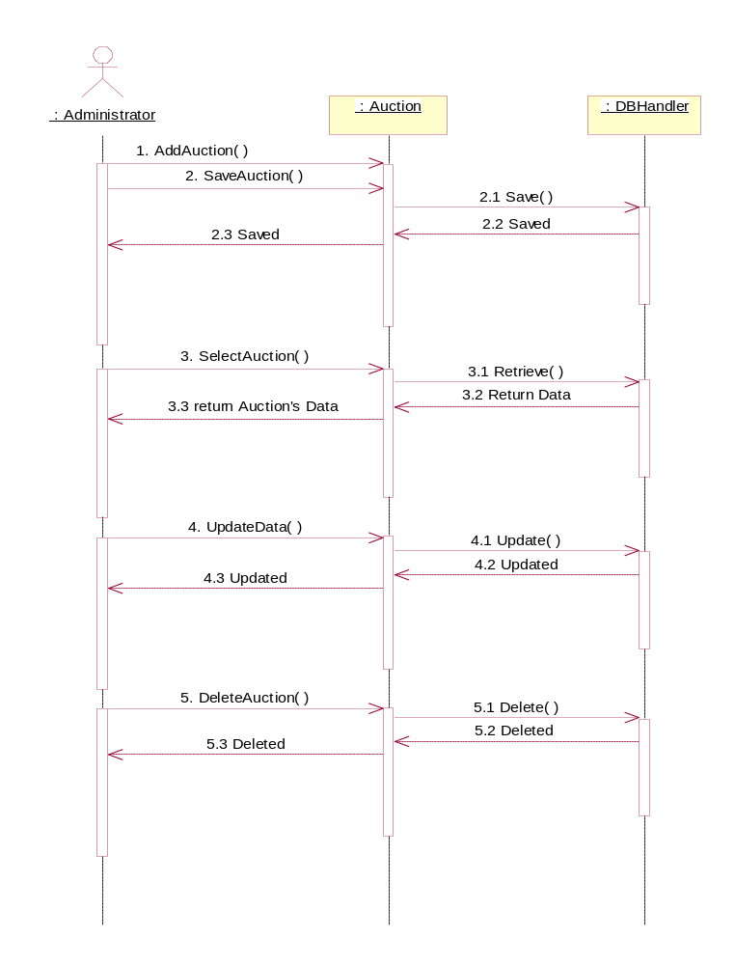

BSD of Use Case: Carpet Management
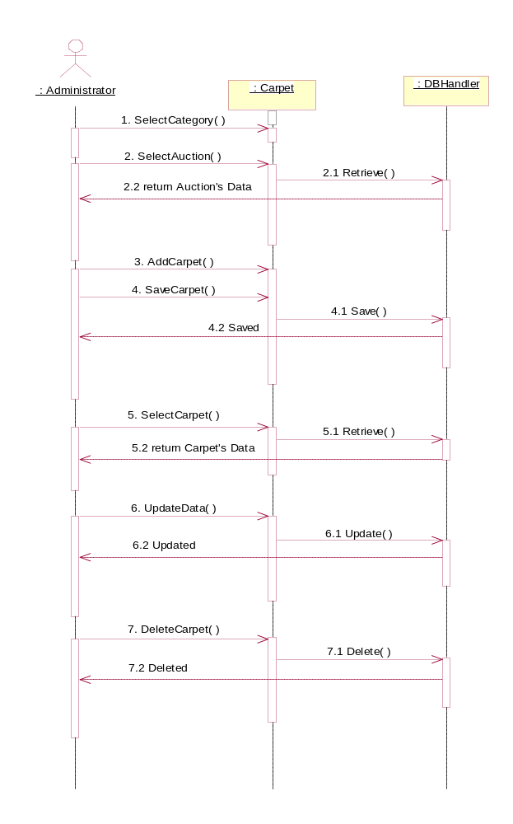

BSD of Use Case: Enter Bidding

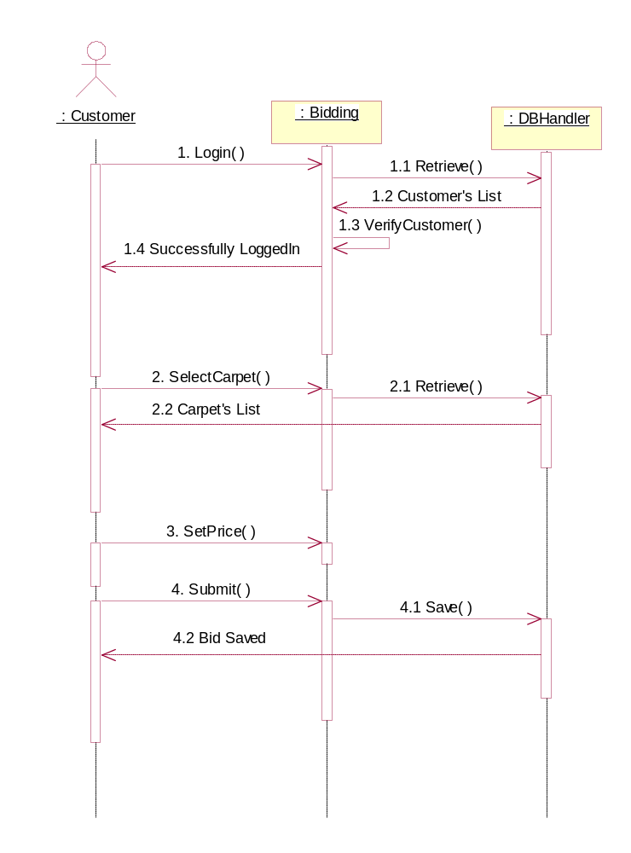

Pseudo Codes

Pseudo Code: Auction Management
1. Administrator adds new Auction.

2. Administrator saves new Auction
2.1 Auction Saved in Database.
2.2 Message sends to Administrator that “Auction is saved”.

3. Administrator selects already existing auction from auctions list.
3.1 Selected auction’s data retrieved from database.
3.2 Auction’s Data sent back to Administrator.

4. Administrator updates Auction’s data.
4.1 Auction’s Data updated in the Database.
4.2 Message sent back to Administrator that “Auction Updated”.

5. Administrator deletes the auction.
5.1 Auction deleted from database.
5.2 Message sent back to Administrator that “Auction deleted”.

Pseudo Code: Carpet Management
1. Administrator selects category of carpet.

2. Administrator selects auction.
2.1 Auction’s Data retrieved from Database.
2.2 Auction’s Data sent back to Administrator.

3. Administrator adds new carpet

4. Administrator saves carpet.
3.1 Carpet saved in the database.
3.2 Message sent back to Administrator that “Carpet Saved”.

5. Administrator select existing carpet from list.
5.1 Carpet’s data retrieved from database.
5.2 Carpet’s data sent back to Administrator.

6. Administrator update Carpet’s data.
6.1 Carpet’s Data updated in the Database.
6.2 Message sent back to Administrator that “Carpet Updated”.

7. Administrator deletes the Carpet.
7.1 Carpet deleted from database.
7.2 Message sent back to Administrator that “Carpet deleted”.

Pseudo Code: Enter Bidding

1. Customer Login into the system.

1.2. Customer’s login information retrieved from Database.
1.3 Customer verified.
1.4 If login information is correct, a message sent back to customer that
“Successfully logged in”

2. Customer selects carpet.

2.1 Carpet’s Data retrieved from Database.
2.2 Data sent back to customer.

3. Customer sets carpet price.

4. Customer submit his Bid.

4.1 Bid saved in the database.
4.2 Message sent back to customer that “Bid Saved”.

Analysis Use Case Diagram
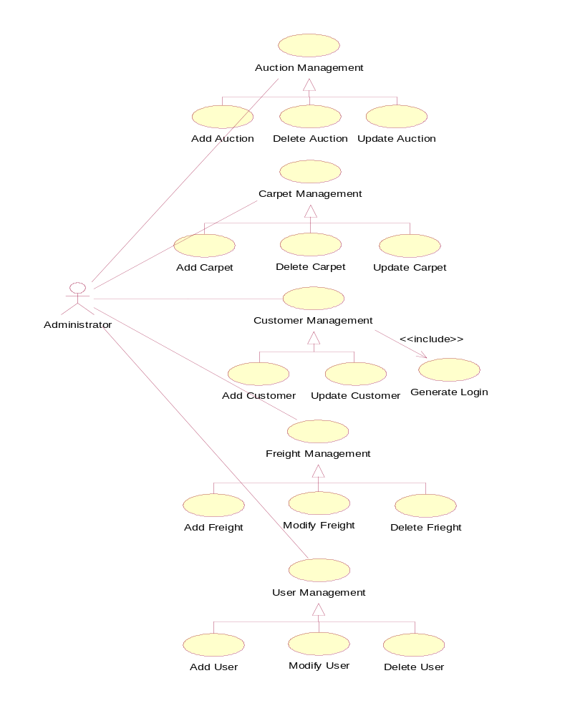
Online Auction Management System

Online Auction Management System

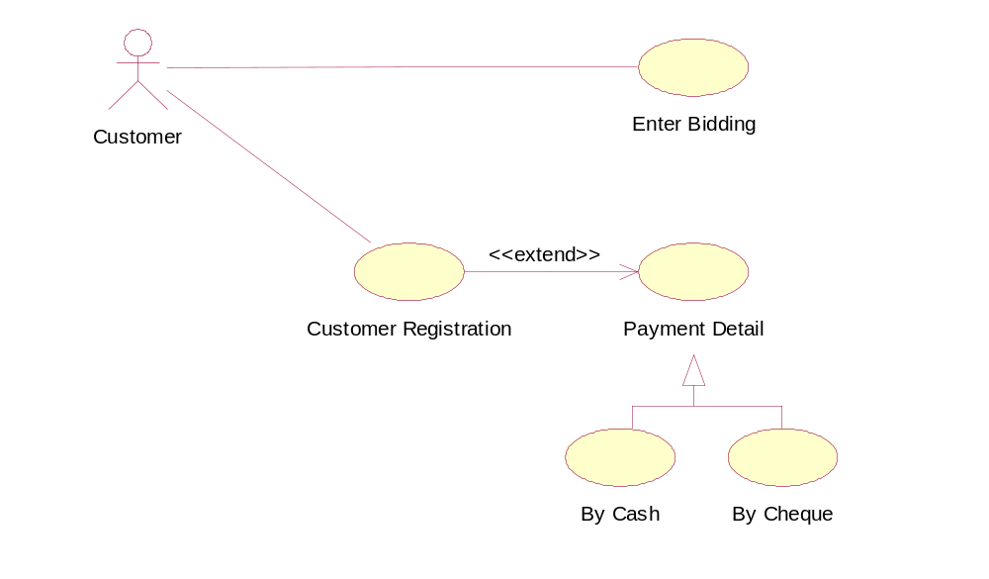

Design Class Diagram

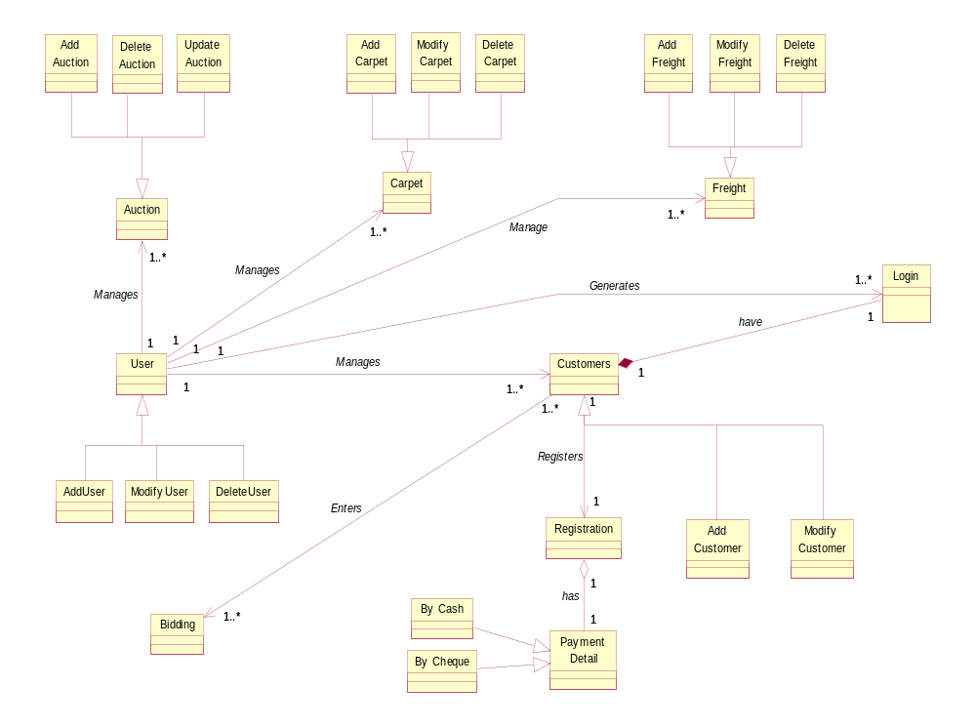

Component Identification

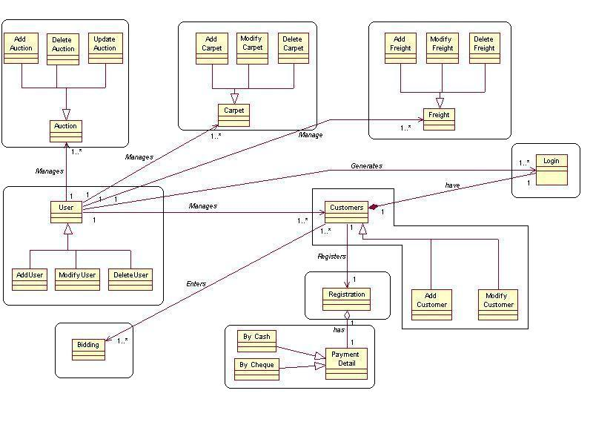

Component Analysis Diagram
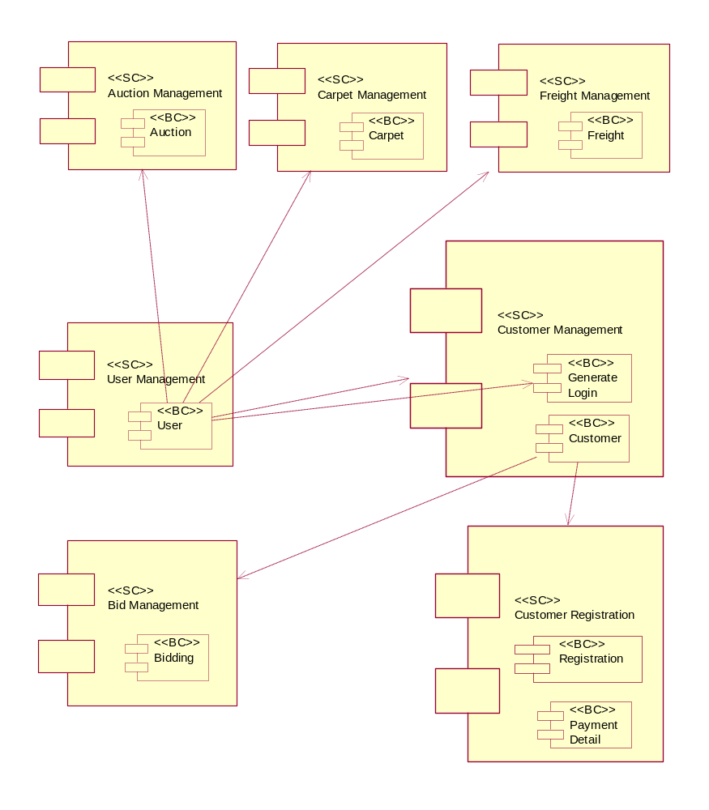

Component Class Diagram
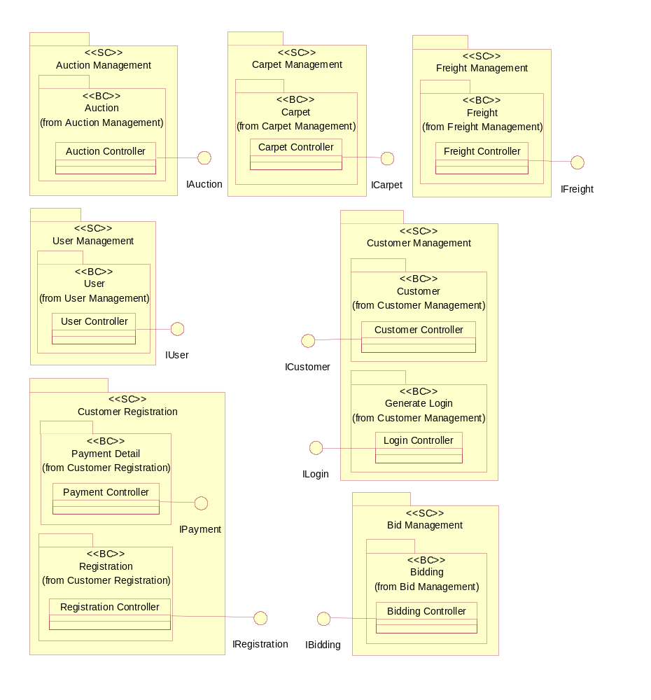

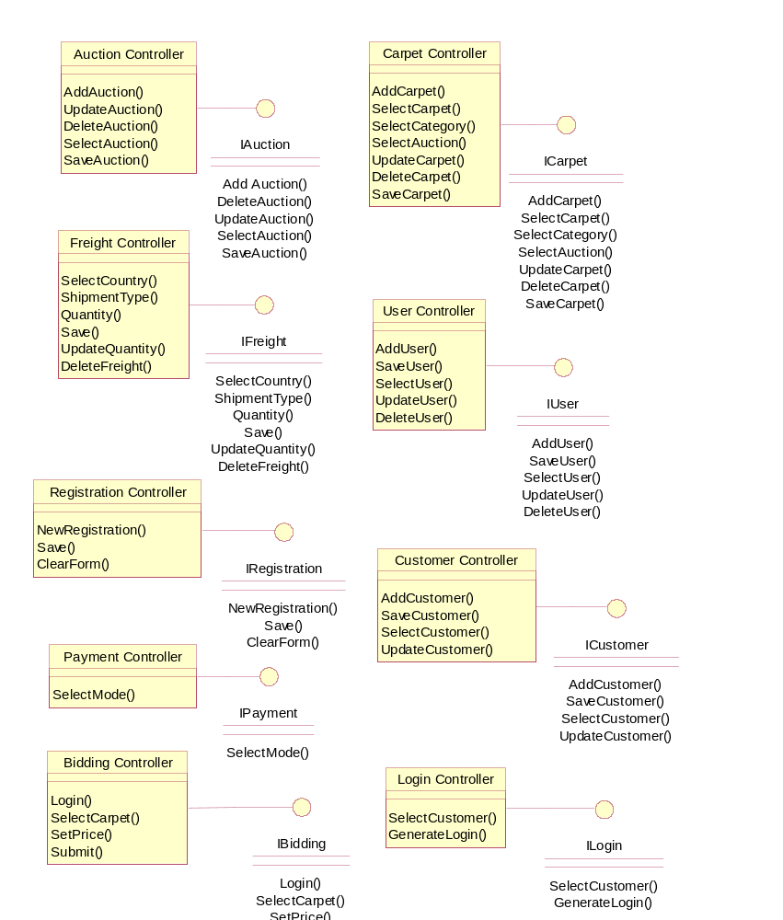
Interface and Functional Specification

Analysis Sequence Diagram

Use Case: Enter Bidding
SelectCarpet
ICarpet
Bidding
Bidding
Controller
Ben : Customer
GetCarpetList
GenerateCarpetList
Return Carpet List
Show Carpet List
Enter Bid Price
Set Bid Price
Submit Bid
Save Bid
Save Bid
Saved
Confirmation

Component Design Diagram with BC Tiers
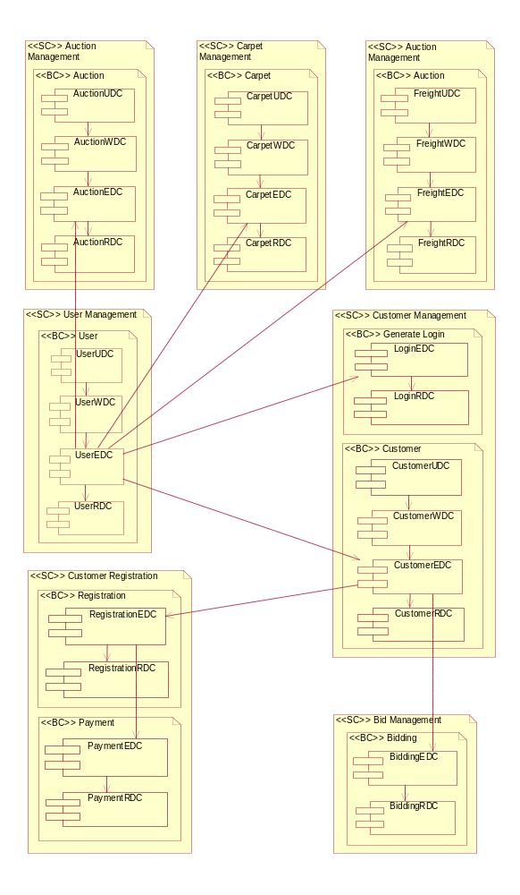

Weber Auctions Site Map

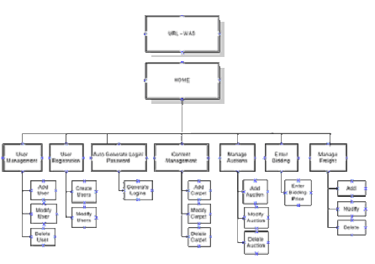

Enter Biding Screen

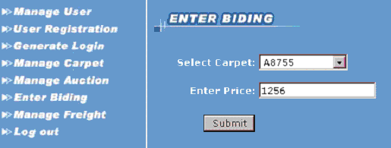

Component Class Design Diagram

WeberAuctions

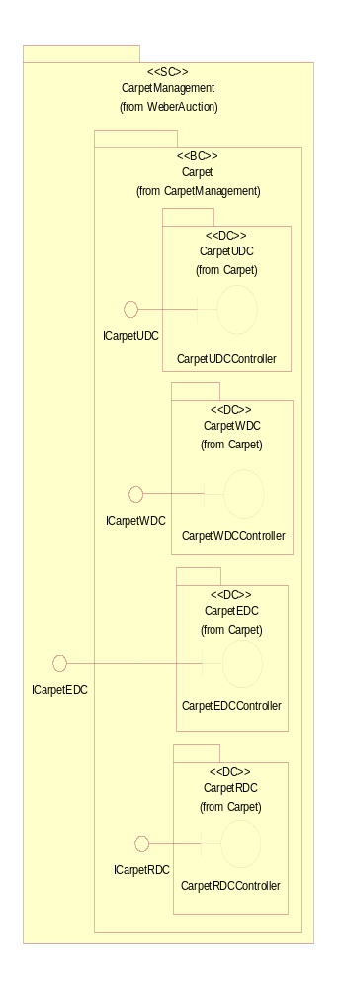
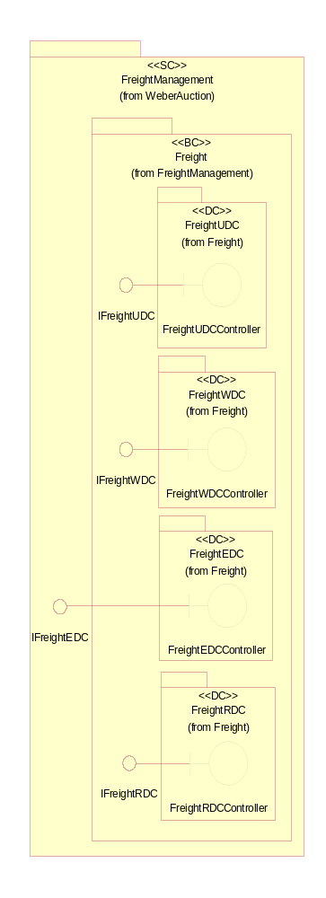
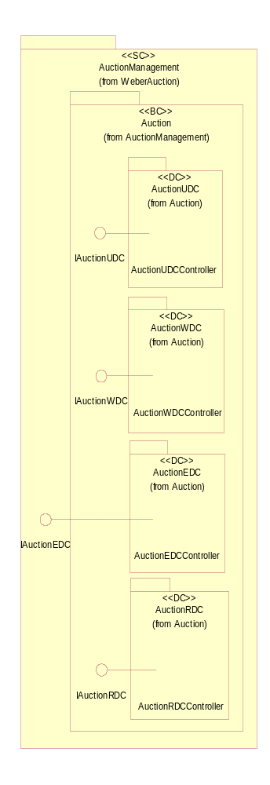

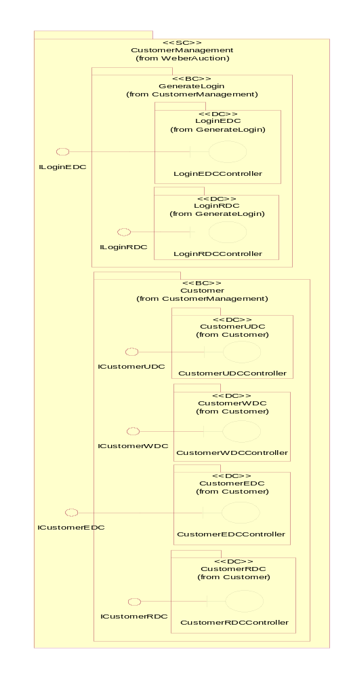
WeberAuction
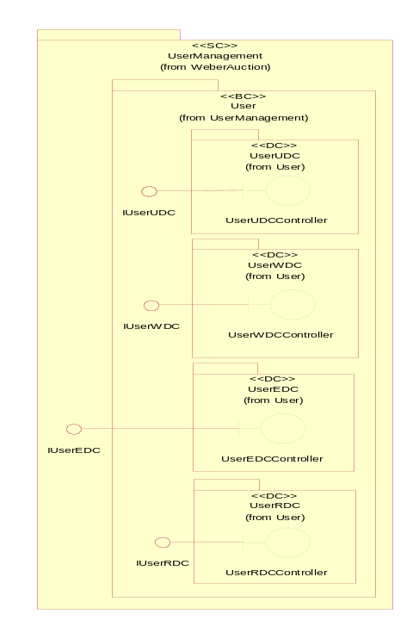

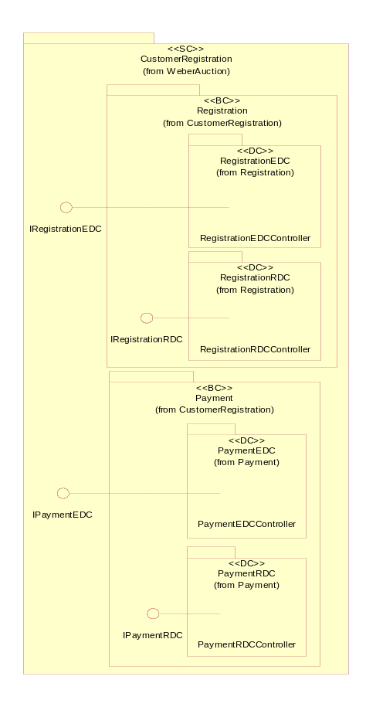

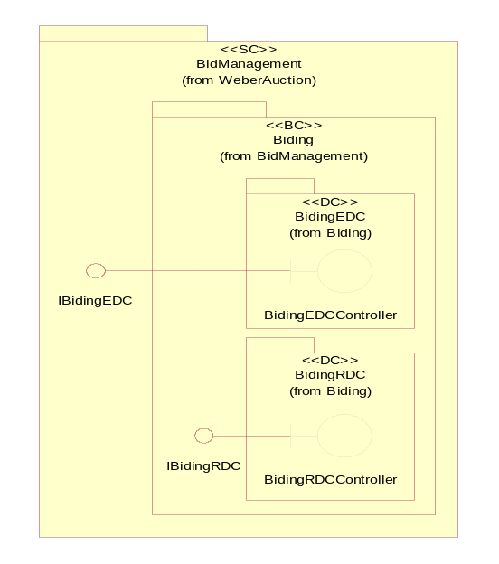

Design Sequence Diagram UDC & WDC
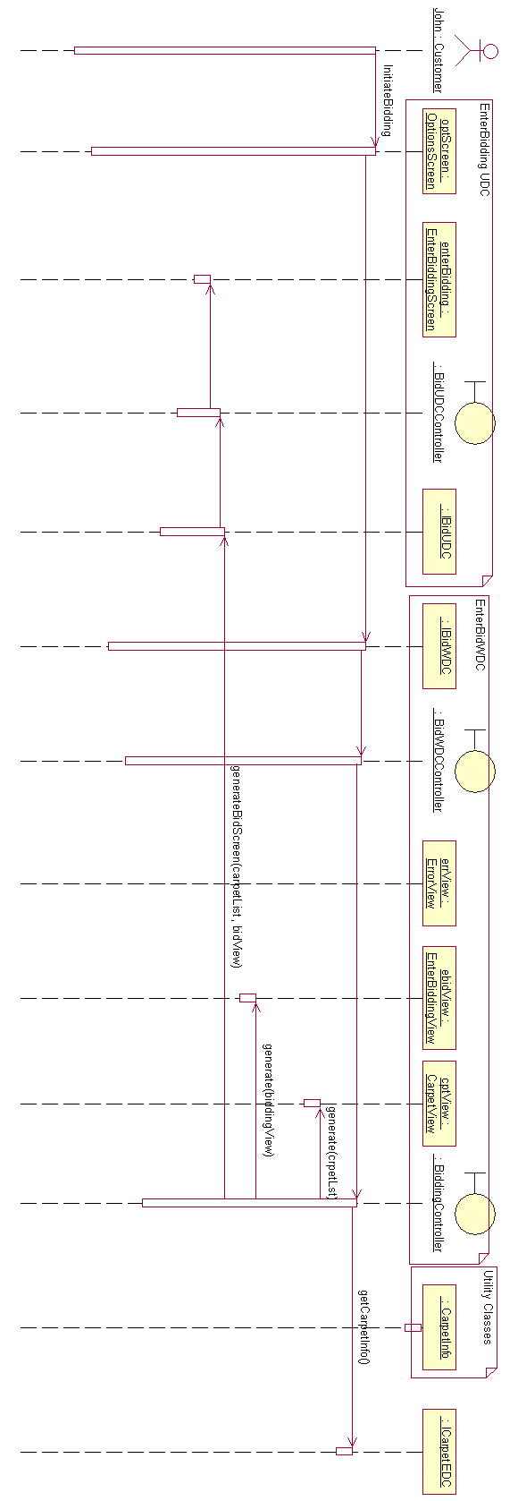

Pseudo code
- Customer selects the enter bid option
- Request submitted to Bidding Controller
- Get carpet details
- Generate Carpet List View
- Generate Enter Bidding View
- Display Enter Bidding View Screen

